CO-2 AT-1
SOFTWARE REQUIREMENT SPECIFICATION

INTELLIGENT INSURANCE CLAIM
MANAGEMENT SYSTEM
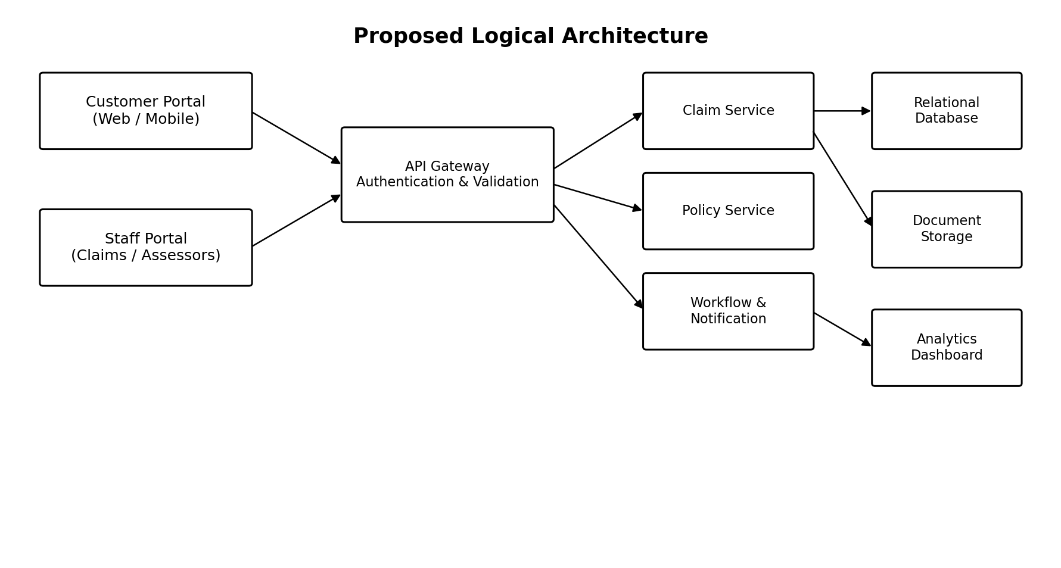

Assessment Details | Information
Course Code | CSA1005
Course Title | Software Engineering
Assessment | CO2 – Scenario-Based Requirement Analysis
Student Name | S.D. Riyaz Kamal
Register Number | 192572049
Department | B.E CSE (A.I)

1. Introduction

1.1 Purpose
This Software Requirement Specification (SRS) defines the proposed Intelligent Insurance Claim Management System (IICMS). It describes the system scope, users, functional and non-functional requirements, interfaces, data, workflows, assumptions, constraints, and validation checks. It is intended for customers, claims officers, assessors, approvers, administrators, developers, testers, and project evaluators.

1.2 Industry Context
Insurance providers manage claims for vehicles, property, travel, health, and other insured assets. A claim typically moves through submission, document collection, verification, assessment, approval or rejection, settlement, and closure. Manual or fragmented processes can lead to delays, inconsistent decisions, repeated requests for evidence, and limited visibility for customers.

1.3 Problem Statement
Design and develop a digital system through which customers can submit claims and supporting documents, while authorized personnel verify evidence, assess losses, coordinate investigations, make decisions, and record settlements. The solution must support configurable workflows and preserve a complete, traceable history of each claim.

1.4 Objectives
- Register and retrieve policy information for eligible customers.
- Accept digital claim submissions and supporting evidence.
- Provide clear claim status and customer communication.
- Assign claims to assessors and record assessment outcomes.
- Manage approval, rejection, settlement, and closure.
- Generate operational analytics while protecting sensitive data.

1.5 Intended Scope
The proposed system covers claim intake through settlement tracking and reporting. It is a requirements-level design; implementation technology, insurer-specific rules, external integrations, and automated decision thresholds must be confirmed during detailed design.
2. Scenario Analysis and Scope

2.1 Stakeholders and Their Needs
Stakeholder | Primary need / responsibility
Customer / Policyholder | Register or access policy details, submit a claim, upload evidence, monitor status, respond to information requests.
Claims Officer | Check completeness, validate eligibility, create tasks, assign assessors, communicate with customers.
Assessor / Investigator | Review documents, inspect loss evidence, record findings, recommend an outcome, flag inconsistencies.
Approver | Review recommendations and policy rules; approve, reject, or return claims for further evidence.
Settlement Officer | Record approved amount, payment reference, payment date, and settlement status.
System Administrator | Manage roles, workflow rules, claim categories, templates, and audit access.
Management / Auditor | View aggregate performance, trace decisions, and review audit records.

2.2 In-Scope Capabilities
- Policy registration and policy-to-claim association.
- Digital claim forms with claim type, incident details, date, location, and requested amount.
- Evidence upload, metadata, versioning, and document review status.
- Configurable claim stages, task assignment, due dates, and escalation.
- Assessment notes, investigation records, decision rationale, and approval history.
- Settlement tracking, notifications, search, and aggregate reporting.

2.3 Out of Scope for Initial Release
- Automatic payment execution through a banking network unless a secure payment integration is separately approved.
- Replacing insurer policy administration or accounting systems.
- Making final claim decisions solely through an AI model without authorized human review.
- Guaranteeing fraud detection; risk indicators are decision support only.

2.4 Business Rules
- A claim must reference a policy and contain mandatory incident information before submission.
- Only authorized roles may assess, approve, reject, or record settlement.
- Every decision must include an actor, timestamp, outcome, and reason.
- A rejected or returned claim must retain its history; records are not silently overwritten.
- Settlement recording is allowed only after the claim reaches an approved state.

3. Functional Requirements
The following requirements use unique identifiers so they can be traced into design, implementation, and testing.
ID | Requirement | Priority
FR-01 | The system shall authenticate users and enforce role-based permissions. | Must
FR-02 | The system shall register policy details or retrieve them from an approved policy source. | Must
FR-03 | The system shall allow a customer to create, save, and submit a claim linked to a policy. | Must
FR-04 | The system shall validate mandatory fields and show actionable validation messages. | Must
FR-05 | The system shall accept supporting files and store document metadata, upload time, and uploader. | Must
FR-06 | The system shall assign a unique claim reference and retain submission timestamps. | Must
FR-07 | The system shall show customers the current status and permitted status history. | Must
FR-08 | The system shall allow claims officers to check completeness and request more information. | Must
FR-09 | The system shall assign or reassign claims to authorized assessors and record assignment history. | Must
FR-10 | The system shall allow assessors to record findings, estimated loss, evidence reviewed, and recommendations. | Must
FR-11 | The system shall support configurable approval paths, including return-for-information, approval, and rejection. | Must
FR-12 | The system shall require a reason for rejection, return, or material decision change. | Must
FR-13 | The system shall record settlement amount, payment reference, date, and settlement status. | Must
FR-14 | The system shall notify relevant users when important claim events occur. | Should
FR-15 | The system shall provide dashboards and exportable summaries for workload, turnaround time, outcomes, and settlements. | Should
FR-16 | The system shall maintain an auditable event history for claim changes and access to sensitive records. | Must
FR-17 | The system shall allow administrators to configure workflow stages, task rules, and notification templates. | Should
FR-18 | The system may flag unusual claim patterns for human review; flags must not automatically determine the outcome. | Could

4. Non-Functional Requirements
Category | Requirement / acceptance target
Performance | For normal load, 95% of common portal actions should complete within 3 seconds, excluding large uploads and external-system delays.
Availability | Target 99.5% monthly service availability, excluding planned maintenance, subject to hosting and operational budget.
Security | Use encrypted transport, secure password handling, least-privilege access, session expiry, and protected document storage.
Privacy | Collect only necessary personal information; restrict access by role and purpose; define retention and deletion rules with the insurer.
Reliability | A submitted claim must not be lost after the system confirms successful submission. Failed operations should provide safe retry guidance.
Auditability | Record claim status changes, assignment changes, decisions, settlement updates, and administrator configuration changes with actor and timestamp.
Compliance | Applicable insurance, privacy, records-retention, and accessibility obligations must be confirmed for the deployment jurisdiction.

4.1 Security and Intelligent Decision Support
The system may use rules or analytical signals to prioritize incomplete, high-value, overdue, or unusual claims. Such signals should be explainable to authorized staff, logged, and reviewed by a human decision-maker. The design must not treat an algorithmic flag as proof of fraud or as an automatic rejection.

5. Actors, Use Cases and Workflow

5.1 Actors
- Customer: submits claims, uploads evidence, tracks progress, and responds to requests.
- Claims Officer: validates intake, manages assignments, and coordinates claim progression.
- Assessor / Investigator: evaluates evidence and records findings and recommendations.
- Approver: approves, rejects, or returns claims according to authority and configured rules.
- Settlement Officer: records payment and settlement details.
- Administrator: configures workflows, roles, reference data, and templates.
- External services (optional): identity provider, policy system, email/SMS gateway, and payment platform.

5.2 Use Case Diagram
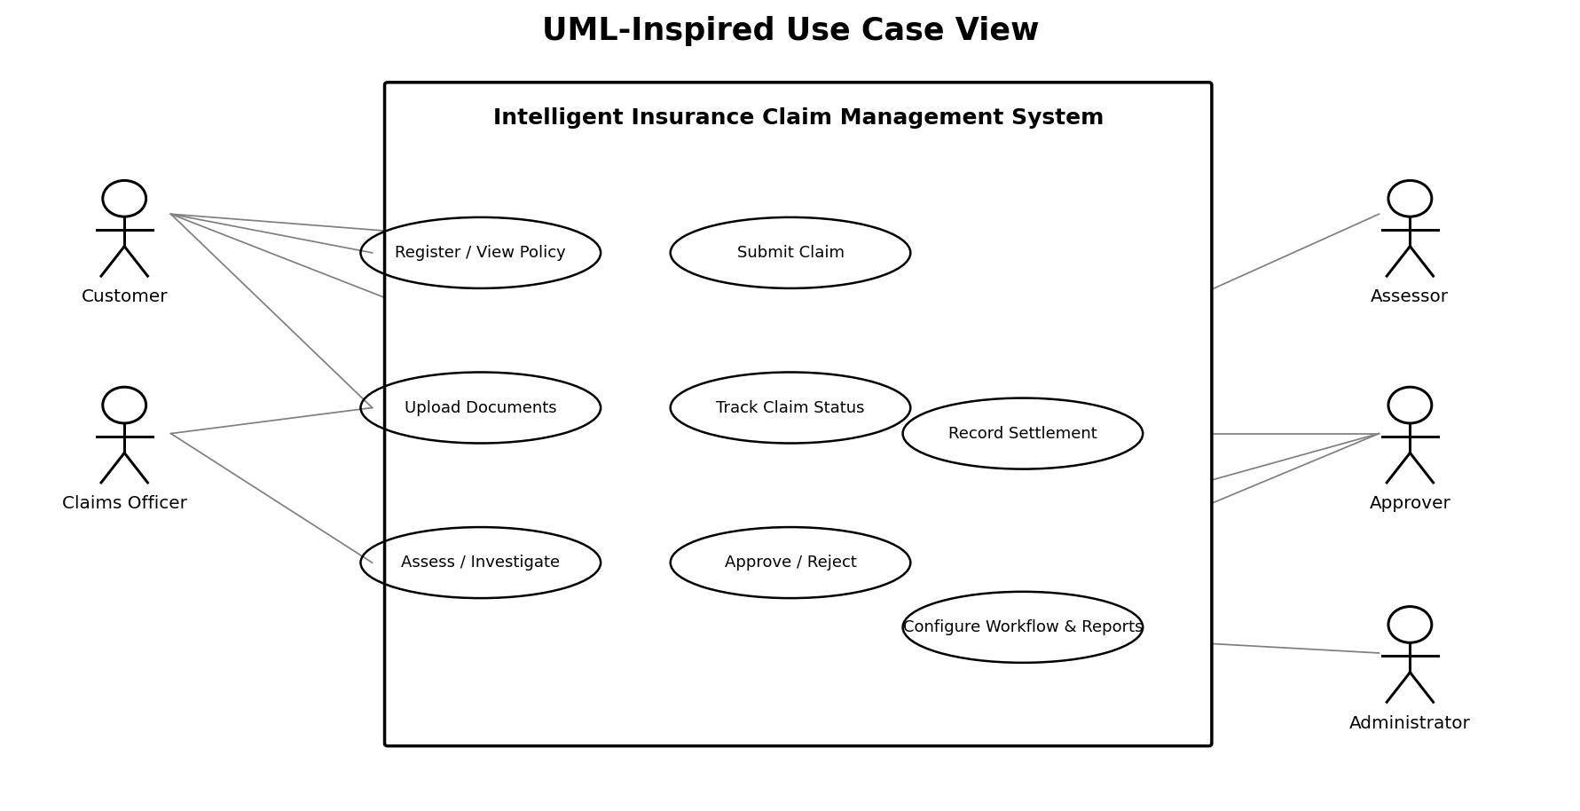
Figure 1. Main actors and use cases (conceptual UML-inspired view).

6. Use Case Specifications and Claim Lifecycle

6.1 Use Case: Submit a Claim
Element | Specification
Preconditions | Customer is authenticated; policy is registered or can be verified; policy is eligible for claim intake.
Trigger | Customer selects “Submit a claim”.
Main flow | 1. Select policy and claim category. 2. Enter incident details and requested amount. 3. Upload available evidence. 4. Review validation messages. 5. Confirm submission. 6. System assigns claim reference and displays status.
Alternative flows | Missing fields: prompt customer to correct them. Upload failure: retain draft where possible and allow retry. Policy mismatch: stop submission and route for policy verification.
Postconditions | Claim is stored, timestamped, linked to policy and documents, and visible in the authorized intake queue.
Acceptance criteria | A valid submission receives a unique reference; required fields are checked; a confirmation is shown only after durable save.

6.2 Use Case: Assess and Decide a Claim
Element | Specification
Preconditions | Claim is assigned to an authorized assessor and required evidence is available or explicitly marked pending.
Main flow | Assessor reviews policy and evidence, records findings and estimate, and submits a recommendation. Approver reviews the record and chooses approve, reject, or return for information.
Exceptions | Suspected inconsistency triggers an investigation task; missing evidence returns the claim to an information-request stage; conflicts of authority block the decision.
Postconditions | Decision, reason, actor, timestamp, and supporting notes are stored in claim history; notifications are queued.

6.3 Workflow Diagram
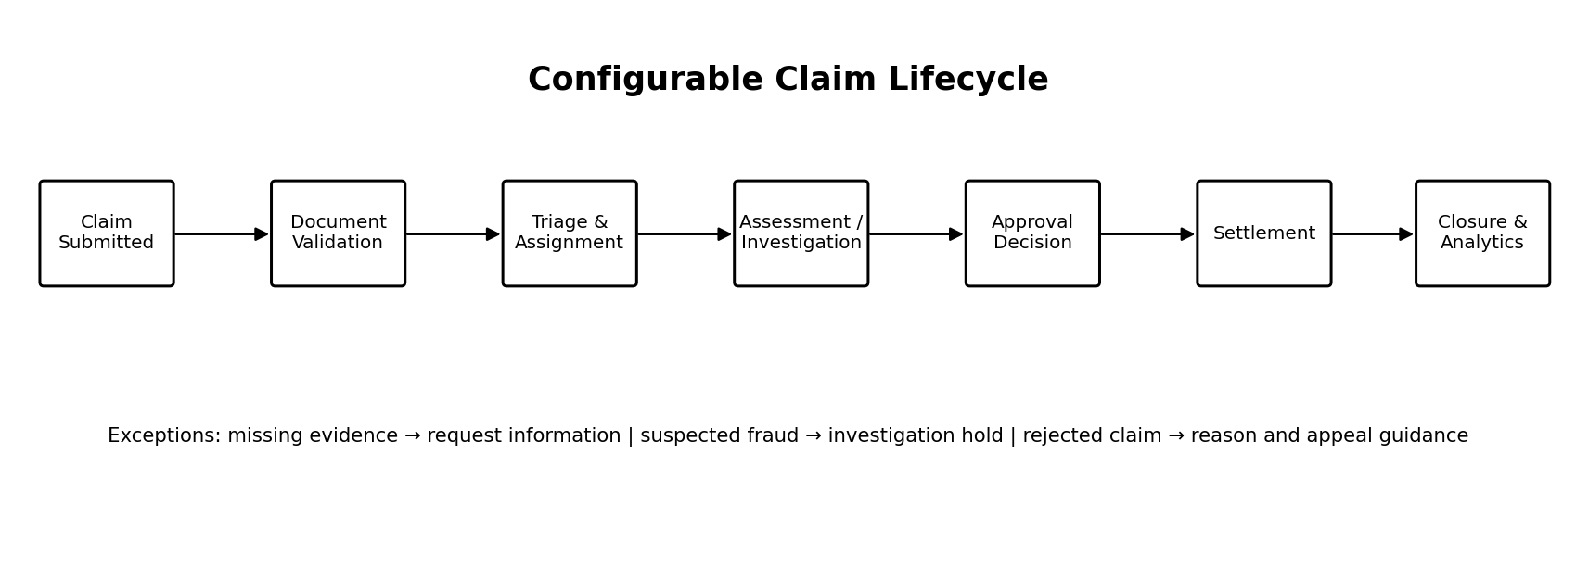
Figure 2. Typical lifecycle; administrators may configure stages and routing rules.

7. System Architecture and External Interfaces

7.1 Proposed Architecture
Figure 3. Logical architecture showing portals, API layer, domain services, and storage/reporting components.

7.2 Component Responsibilities
Component | Responsibility
Customer Portal | Claim entry, document upload, status view, and requests for information.
Staff Portal | Queues, assessment workbench, decision actions, settlement entry, and reports.
API Gateway / Identity | Request validation, authentication, authorization, throttling, and API routing.
Claim Service | Claim lifecycle, references, state transitions, and history.
Policy Service | Policy lookup, coverage metadata, and eligibility checks through approved sources.
Workflow & Notification | Configurable routing, due dates, reminders, escalations, and event notifications.
Document Storage | Encrypted evidence files, metadata, version control, and access controls.
Analytics Dashboard | Aggregated workload, cycle-time, decision, and settlement metrics.

8. Data Requirements, Assumptions and Constraints

8.1 Core Data Entities
Entity | Important attributes
Customer | Customer ID, name, contact details, preferred communication channel.
Policy | Policy ID, customer ID, policy type, coverage dates, status, relevant coverage reference.
Claim | Claim ID, policy ID, category, incident date, description, requested amount, current status.
Document | Document ID, claim ID, file reference, type, upload timestamp, review status, version.
Decision / Audit Event | Decision ID, outcome, reason, actor, timestamp; audit event type and before/after values where appropriate.
Settlement | Settlement ID, claim ID, approved amount, payment reference, date, status.

8.2 Assumptions
- Customers have access to a supported browser and a usable contact method.
- Authorized staff receive training and have role-specific accounts.
- Workflow stages can vary by claim category and are configured by an authorized administrator.
- Any external systems expose approved interfaces or provide controlled manual alternatives.

9. Analytics, Validation and Conclusion

9.1 Claim Analytics
Metric | Definition / use
Claims received | Count of claims submitted during a selected period; supports demand planning.
Average processing time | Elapsed time from submission to decision or closure, reported by claim category.
Stage ageing | Number of claims and time spent in each workflow stage; highlights bottlenecks.
Pending information | Claims waiting for customer or third-party evidence.
Decision distribution | Approved, rejected, returned, or under-investigation claims, with category filters.
Settlement totals | Approved and settled amounts over a period, subject to role-based access.

9.2 Requirement Completeness and Consistency Validation
- Traceability: FR-01 to FR-18 map to identified stakeholders, use cases, and test cases.
- Completeness: intake, evidence, assessment, decision, settlement, notifications, history, and reporting are covered.
- Consistency: settlement is permitted only after approval; rejection and return actions require reasons; permissions are role-based.
- Operational validation: conduct walkthroughs with claims staff and representative customers before finalizing workflows.

9.3 Risks and Mitigations
Risk | Mitigation
Incomplete or illegible evidence | Checklist, upload validation, clear requests for missing information.
Incorrect automated flag | Human review, explainable indicators, monitoring, and no automatic rejection.
Unauthorized disclosure | Least privilege, encryption, access logs, secure file links, and periodic access review.
Workflow misconfiguration | Versioned configurations, test environment, approval before activation, rollback.
Integration outage | Retry queues, clear user messaging, reconciliation reports, and manual fallback where approved.

9.4 Conclusion
The proposed Intelligent Insurance Claim Management System provides a structured digital workflow from claim submission to settlement and reporting. Its core value is traceability: policy details, documents, assignments, assessments, decisions, and payments are linked to a complete claim history. Configurable workflows and carefully governed decision-support analytics can improve speed and transparency while keeping final decisions accountable to authorized personnel.

